The Leinster School of Music & Drama
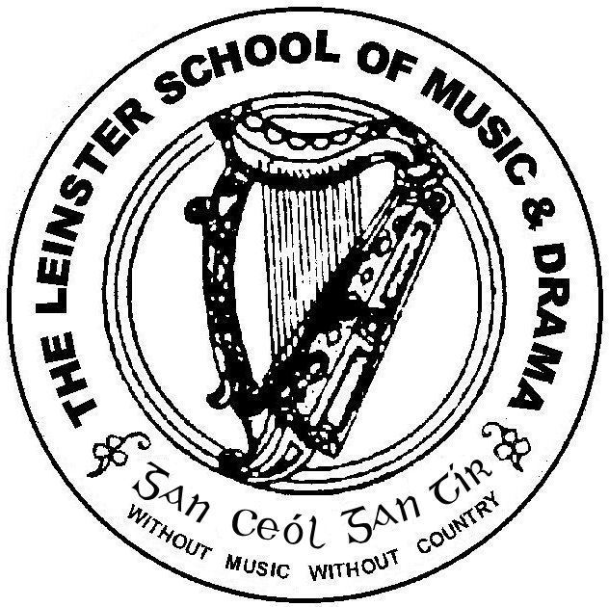

Est. 1904

Associate Diploma December 2012

Please number your answers and your pages carefully.
Please answer 5 questions. Questions 1 and 2 are compulsory.*
Time allowed: 3 hours

Question 1*
Imagine that you have been cast in a major role in a Shakespearean play. Discuss how you would approach the task of exploring the text, its language, your role and the performance of Shakespearean verse.

Question 2*

J.G.Marash says, “The first essential for correct public speaking is breath control.” Discuss, in detail, the role that breathing plays in developing voice production. Illustrate your answer with reference to your own breathing exercises and vocal practice.

Question 3
You have been invited to present a short recital as part of a Christmas entertainment staged in an old peoples’ home. Discuss how you would develop an appropriate theme and programme, how you would maintain balance and variety, and present the recital, maintaining the interest of your elderly audience.

Question 4
Improvisation is used extensively in many Speech and Drama classes. Outline the varying improvisational strategies, techniques and exercises and discuss their benefits. Refer to your own personal improvisational practise.

Question 5
Give a critique of a production you have seen lately. Discuss its appeal for you, if any, from the perspectives of direction, setting and costume, the performance of the actors and audience engagement.

Question 6
Choose an Irish playwright or writer of your choice. Discuss his or her work from the perspective of theme, characterisation and style.

Question 7
You have been invited to direct a play for your local Youth Theatre. Discuss your approach as director, strategies and techniques you would adopt, and how you would develop a rapport with this young cast.

Question 8
You have been invited to give some advice to new readers of the liturgy in Church. What advice, techniques, strategies and exercises would you give to these inexperienced readers?

