*geteduroam app*

**Step 1** - Open PlayStore on your Android Device or Apple Store on your iOS device (Apple). Search for geteduroam and install app.

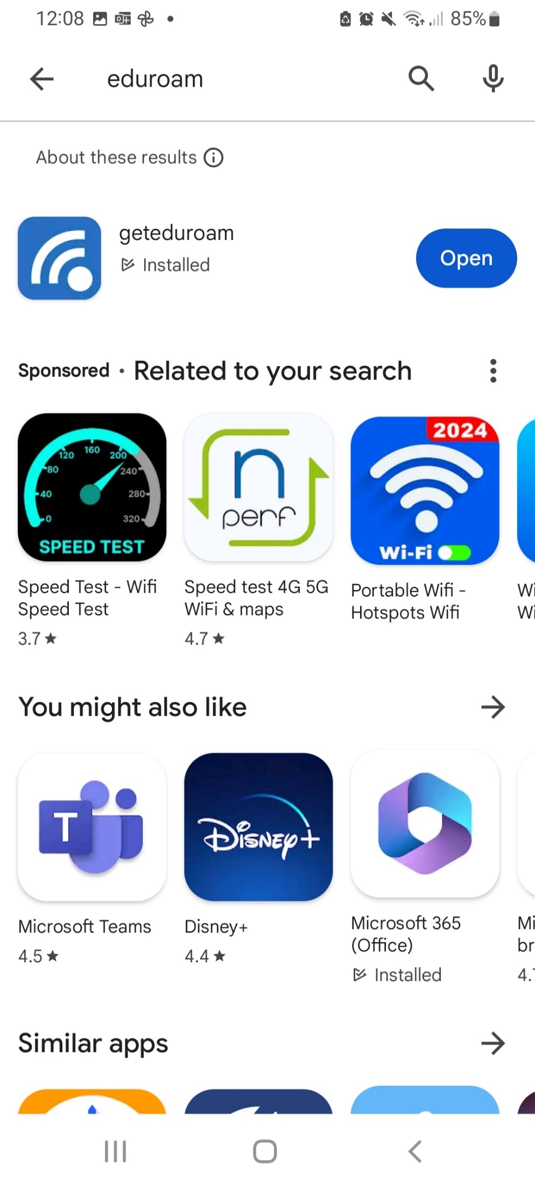

**Step 2** – In ‘Institution’ search Griffith College and select from the dropdown. From ‘Profile’ select ‘Student’. Click ‘Next’ -

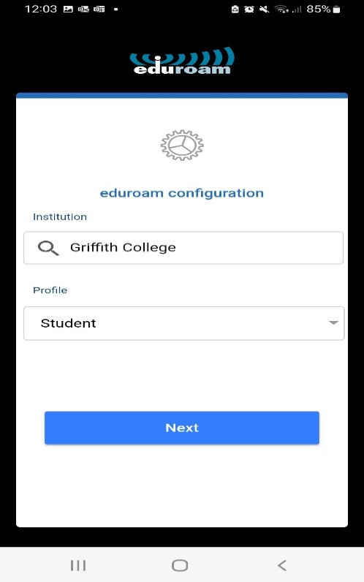

**Step 3** - Install the profile and if successful, you will be notified. You should now be connected Eduroam.

If you run into issues, please email [helpdesk@griffith.ie](mailto:helpdesk@griffith.ie) or scan the below QR. In your email, please include a description of the issue and provide screenshots of any errors.

