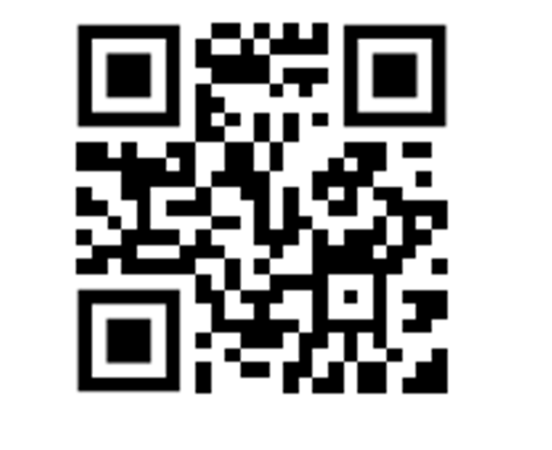**Please scan the below QR code to contact the IT department by email.**