1. **Scan barcode below to bring you to the Printing Services.**

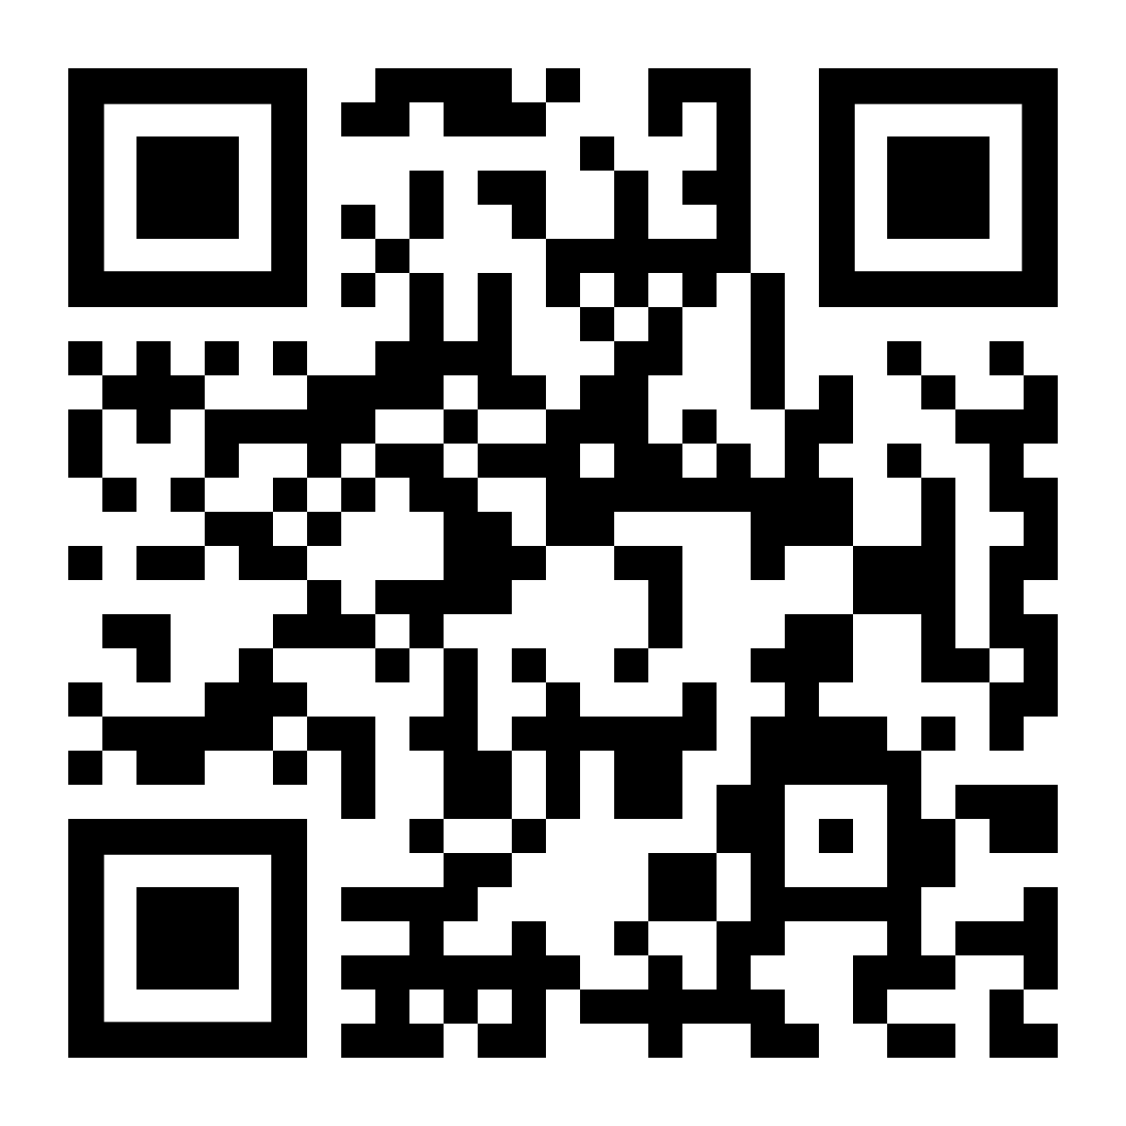

1. **Log into** [**https://printing.griffith.ie/user**](https://printing.griffith.ie/user) **using your Griffith email address and password.**

**User name:** firstname.lastname@student.griffith.ie

**Password:** Date of Birth - (dd/mm/yyyy)

If you are using a mobile device please choose ‘view in desktop mode’ at the bottom of the screen.

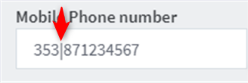

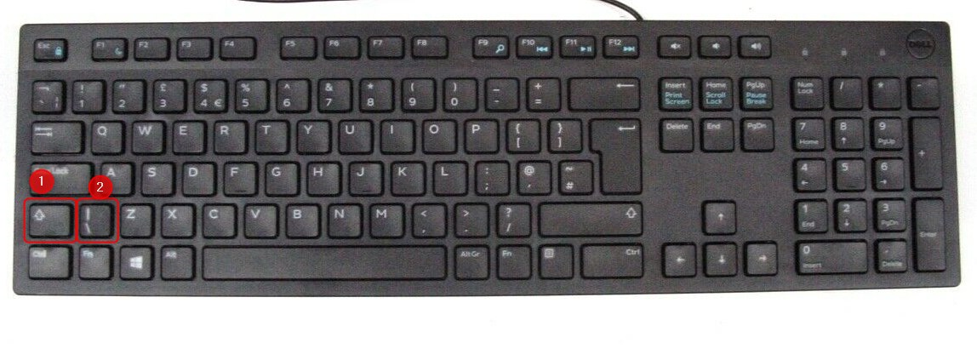The Character can be inserted by pressing ‘Shift’ and ‘Z’ as shown below

1. **Click on Add Credit and enter your personal details* to confirm**

*Please ensure you enter your mobile number correctly by entering the character after the country code

1. **Log onto PC using your Griffith email address and password.**

Open the document you wish to print and select the Black and White Printer from the drop-down selection.

1. **Log into printer using your Griffith email address and password.**

Select jobs to print.