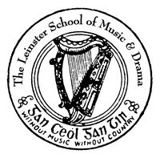

The Leinster School of Music and Drama

Professional Diploma for Teachers

Paper 1: 100 marks

December 2012

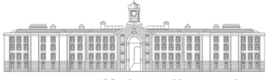
GRIFFTH COLLEGE DUBLIN

All three parts to be answered

Part 1:-Aural Training and General Musicianship (30 Marks)

All Three sections in this section to be answered

- Transpose the following excerpt up a Diminished 5th and insert the new key signature

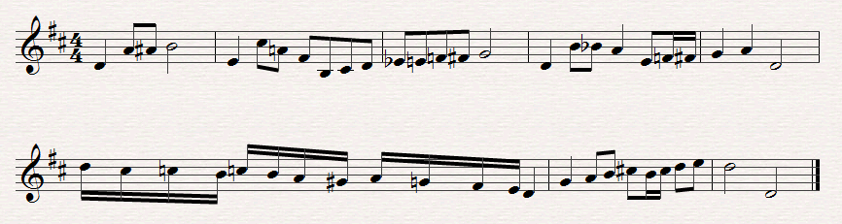

- Answer (a) or (b)

- Identify the following Intervals

______ ______ ______ ______ ______
Or

- Above the following notes write the following triads

Diminished 1st. Augmented Minor 2nd. Major 2nd Diminished 2nd
Inversion Root position Inversion Inversion Inversion

- Rewrite the following as it would be played

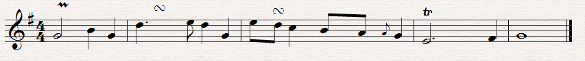

Part ii: Harmony (4o marks)

One question only to be answered in this section

- Harmonise the following extract by adding parts for Soprano, Alto and Tenor

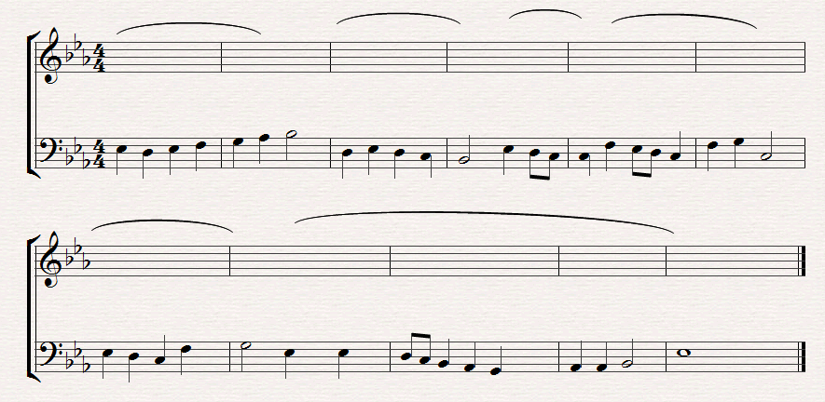

Or

2, Complete the following extract

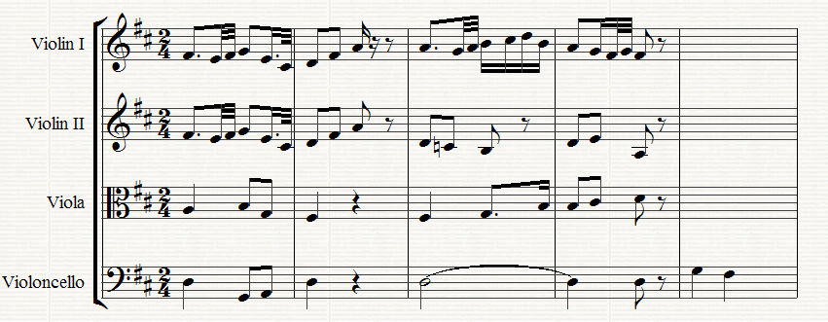

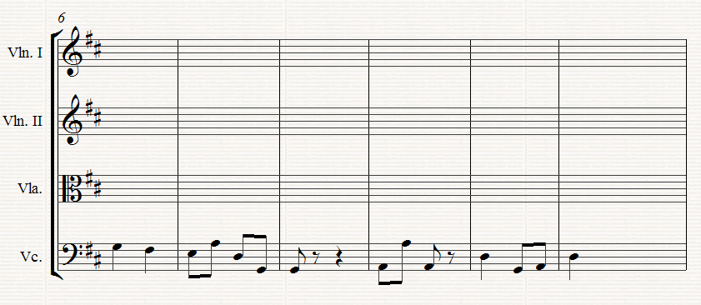

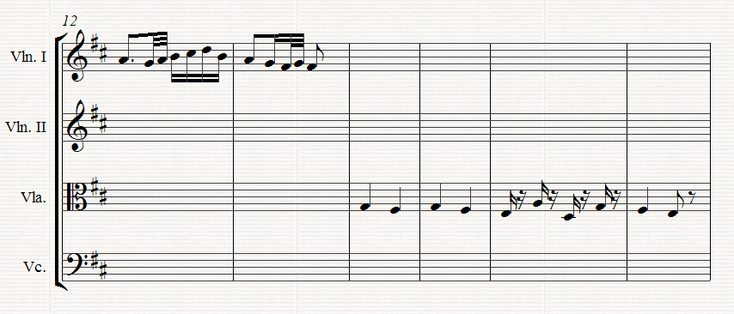

Part iii:- Contrapuntal Harmony (30 Marks)

One question only to be answered in this section

- Complete the following by adding a part for Bass voice

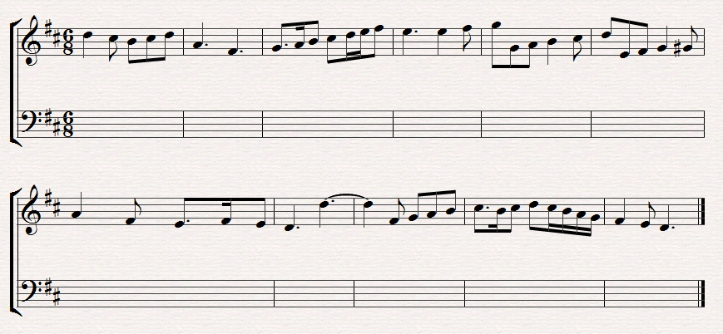

Or

- Complete the following extract by adding an upper part.

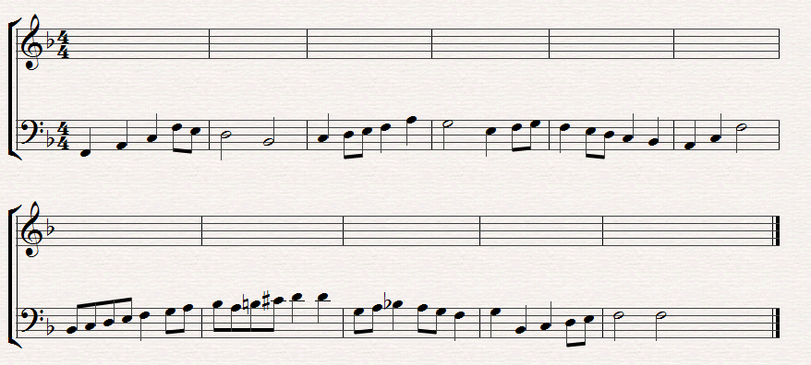

The Leinster School of Music and Drama

Professional Diploma for Teachers

Paper 2: 100 marks

December 2012

GRIFFTH COLLEGE DUBLIN

All three parts to be answered

Part 1: Teaching methods (40 marks)

Answer one question from section A and one from section B

Section A

A1 How would you seek to convince a pupil that the practice of scales and arpeggios in not only necessary but, done properly, also interesting. Outline steps you would take to make them as interesting as possible.

Or

A2 In developing an astute ear, rhythm and pitch are the main elements. Outline how you would cultivate these facilities in a student. Illustrate with musical examples where necessary

Section B

B1 Outline how you would explain the function of the sustaining pedal on the piano and what steps you would take to cultivate that technique. Cite some pieces which would help your pupil improve this technique.

Or

B2 Cantabile is essential in the performance of music. Outline how you would develop this to a high standard with a senior student

Part 11: History (30 marks)

Candidates should answer two questions only in this section – both questions must be from the same chosen historic period. Include musical citations and/or examples where relevant to support you answer

1685 – 1800

- Compare the Oratorios of Bach and Handel

- Assess the contribution of Haydn to the development of the Symphony

- Discuss the importance of Mozart as a composer of Opera

1800 – 1900

- Which composer do you consider contributed most to the development of the Piano in the 19th century? Outline the reasons for your selection.

- Discuss the development of the symphony in the latter part of the 19th century

- Opera was a major form of composition in this century. Which composer would you consider the master of this genre.

1900 – 1999

- The 20th century saw the emergence of a number of eminent Irish composers. Select one composer and assess their contribution to the Classical Music repertoire.

- Outline the features of Impressionism with special reference to the Music of Debussy and Ravel.

- In the 20th century composers experimented with various new techniques. List some of these composers and discuss the development of any one of them

Part iii: Analysis (30 marks)

Study the attached copy of Mozart’s Sonata in C, K. 309, 1st. movement and answer the following questions.

(i) Using bar numbers outline the form of the movement, including the principal key changes

- Describe the chords (including position) in bars 35 - 42.

- What key is suggested in bars 67 – 68

- Identify the cadence and key between bars 21 - 22 and 81 - 82

- Give the meaning of each of the following:-

Allegro
Cresc
sf
tr
sfp

