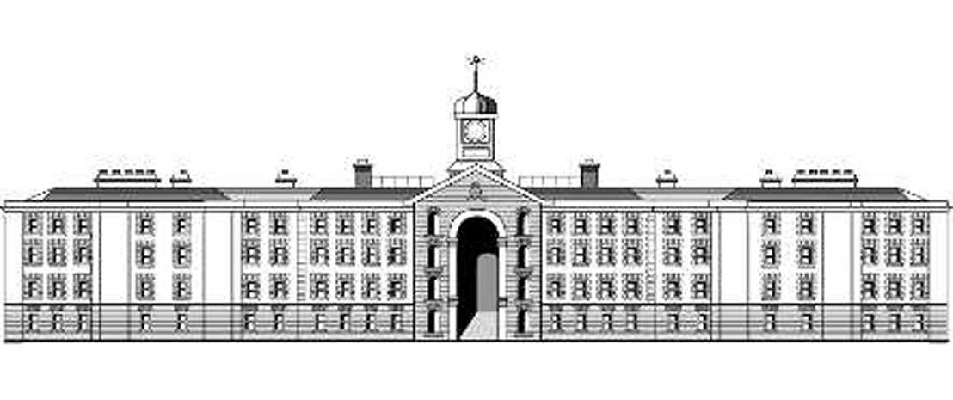

**Opportunities for Programmes Administrators**

# Background:

Griffith College is delighted to announce **four** new Programmes Administrator positions in its Springboard Department. Two of the positions are being offered in Dublin with one each in Cork and Limerick.

These new positions arise from the College’s recent success in being granted government funding by the Higher Education Authority (HEA) to provide 450 ‘fully funded’ places for students in 2015/6.

The funded places are being offered across a number of the College’s faculties with programmes in Computing, Design, Media and Graduate Business in addition to specialist programmes in Music Production for Games, and in Industrial Engineering. A full list of the programmes is provided in Appendix 1.

# Role: Springboard Programmes Administrator

The role will involve:

* Managing the administration processes relating to all stages of the learners’ engagement with the College: from application and entry, through attendance and assessment, through to their graduation, including: This will include:
  + Responsibility for the collection, management and integrity of all learner data
  + Communicating with learners in respect of their programme to ensure its smooth, efficient and professional delivery
  + Management of programme processes in accordance with the College’s Quality Assurance and Enhancement Requirement (i.e. most recent QQI approved QA Policies, Procedures, Practices and Guidelines)
* Assisting Programme Directors of Springboard Programmes within existing or new faculties to ensure the smooth running of the Springboard programmes, for example in relation to the management of timetables, assessments, examinations, deferrals, special events, etc.
* Providing and arranging pastoral supports for learners undertaking the programme
* Working closely with other members of the College to ensure the quality of the programme’s operation and delivery (e.g. Exams, QAE, Central Administration, etc.)
* Liaising with other members throughout the College in respect of the general operation of the programme (e.g. reception, marketing, IT Services, Maintenance, etc.)

As the programmes are funded by the HEA and are directly targeted at preparing learners for emerging employment opportunities in Ireland, the following responsibilities will also apply:

* Assisting with the application process from initial enquiry, selection, registration and induction.
* Preparing reports for the HEA in respect of student attendance, performance and progress in relation to employment
* Liaising with and assisting other Springboard personnel to ensure the overall smooth running of the programme, for example by representing the Springboard Department at Open Evenings, Marketing Events, Graduations, etc.

As with all members of the College, you may at times be required to assist, and be assisted by others, in respect of other responsibilities.

**Likely Profile of Experience**

**Programmes Administrators are expected to have:**

* Strong organisational and IT skills
* Previous administrative experience
* An ability to work independently and as part of a team
* Ability to work to agreed goals and to contribute to the improvement of existing practices
* Direct experience in or of third level education - further or higher education
* Professional approach to work responsibilities – e.g. attention to detail, coherent presentation of work, timely completion of activities, etc.
* Superior interpersonal and communication skills in the respectful interactions with students, staff and external bodies
* Ability to be entrusted with sensitive and confidential data in respect of students and staff
* To act at all times in a manner that reflects well on themselves and on the College

**Reporting Lines – Location**

The positions are being made available in Griffith College’s Springboard Department as follows:

Griffith College Dublin (SCR Campus)* 2 positions (full / part-time considered)

Griffith College Cork 1 part-time position (3 days per week)

Griffith College, Limerick 1 part-time position (3 days per week)

Programmes Administrators will have a dual reporting line. The first reporting line will be to the Programme Directors involved in managing the Springboard Programmes. The second reporting line will be to the Head of Academic Administration who will provide direction and support in relation to administrative processes (e.g. Examinations, Registration, etc.).

**Contract Duration**

In the case of new appointments, contracts will be limited to a fixed period of 11 months. In the case of existing employees being offered a role, their contracts would reflect and respect their previous roles and would not be similarly restricted to 11 months.

**Appendix 1: Springboard Courses**

**Number of Funded Places Available**

**Campus Location**

**COMPUTING – GCD**

* Higher Diploma in Science in Computing [ICT Skills Conversion] 40
* Higher Diploma in Science in IT Infrastructure [ICT Skills Conversion] 40
* Higher Diploma in Science in Web Development [ICT Skills Conversion] 40
* Master of Science in Big Data Management and Analytics 30

**COMPUTING – GCL**

* Higher Diploma in Science in IT Infrastructure [ICT Skills Conversion] 20
* Higher Diploma in Science in Web Development [ICT Skills Conversion] 20

**COMPUTING – GCC**

* Higher Diploma in Science in Computing [ICT Skills Conversion] 20

**DESIGN - GCD**

* Diploma in Building Information Modelling (BIM) and Graphic Illustration 30
* Diploma in Project Management, Business Planning & Entrepreneurship in the Built Environment 30
* Diploma in Retrofit, Conservation and Sustainability 30

**GRADUATE BUSINESS SCHOOL - GCD**

* Diploma in Investment Operations and Compliance 20

**GRADUATE BUSINESS SCHOOL - GCL**

* Diploma in Investment Operations and Compliance 20

**MEDIA - GCD**

* Diploma in Digital Communications for Enterprise 25

**MEDIA - GCC**

* Diploma in Digital Communications for Enterprise 20

**MUSIC PRODUCTION (with inputs from Windmill Lane) - GCD**

* Certificate in Music Production for Games 25

**INDUSTRIAL ENGINEERING (in association with the Institute of Industrial Engineers) - GCD**

* Diploma in Industrial Engineering 20

**SPRINGBOARD PROGRAMMES ADMINISTRATORS**

GCD: Central Administration / Springboard Office

Two full-time Programmes Administrators

GCC: Support / Administration of GCC Springboard Programmes

Programmes Administrator (Part-time) - Estimate 3 day week

GCL: Support / Administration of GCL Springboard Programmes

Programmes Administrator (Part-time) – Estimate 3 day week